Name: Nafinur Leo

Id: 20-42195-1

Course: Computer Organization And Architecture

Section: C

Date: 22-02-2022

Home Task

Task1:

Code:

.MODEL SMALL

ORG 100H

.CODE

MAIN PROC

MOV AX,-8

CMP AX,0

JNL PRINT

IF_NEG:

NEG AX

PRINT:

MOV DX,AX

ADD DX,48

MOV AH,2

INT 21H

END:

MOV AH,4CH

INT 21H

MAIN ENDP

END MAIN

RET

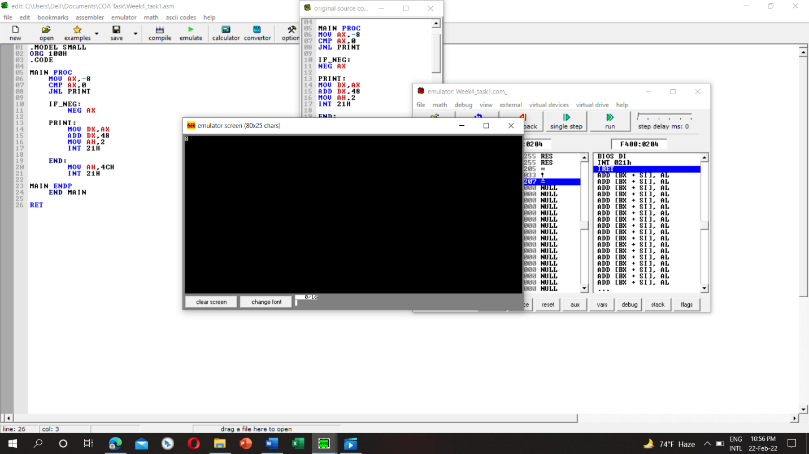

Task2:

Code:

.MODEL SMALL

ORG 100H

.CODE

MAIN PROC

MOV AL,35H

MOV BL,37H

CMP AL,BL

JNBE ELSE_

MOV DL,AL

JMP DISPLAY

ELSE_:

MOV DL,BL

DISPLAY:

MOV AH,2

INT 21H

END:

MOV AH,4CH

INT 21H

MAIN ENDP

END MAIN

RET

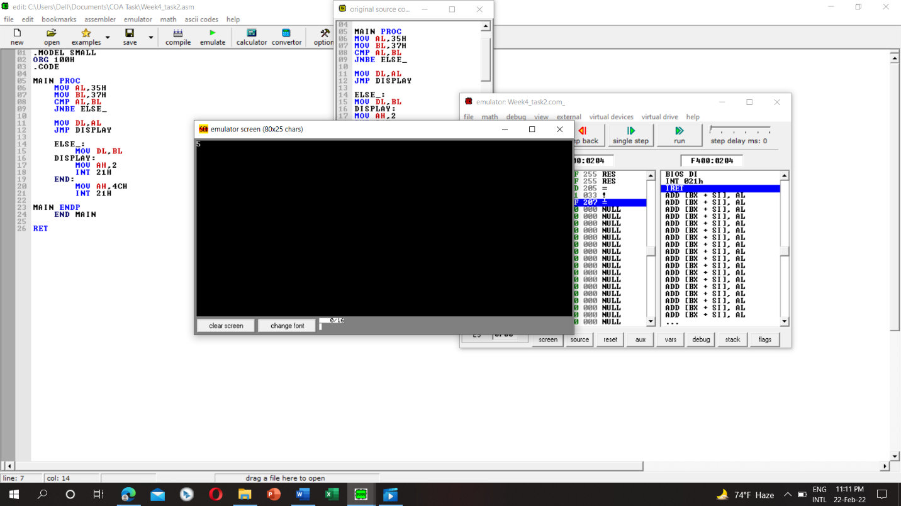

Task3:

Code:

.MODEL SMALL

ORG 100H

.CODE

MAIN PROC

MOV AX,-5

CMP AX,0

JG GREATER

JL LESS

JE EQU

LESS:

MOV BX,1

JMP END

EQU:

MOV BX,0

JMP END

GREATER:

MOV BX,1

JMP END

END:

MOV AH,4CH

INT 21H

MAIN ENDP

END MAIN

RET

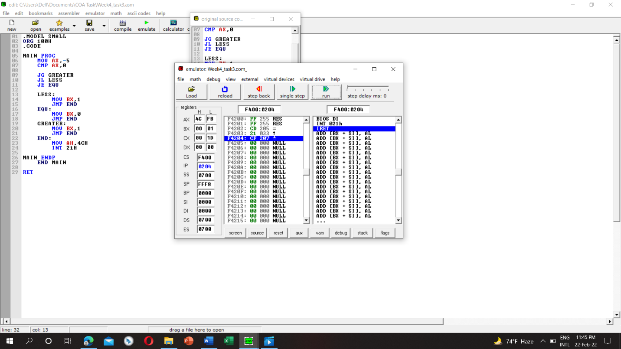

Task4:

Code:

.MODEL SMALL

ORG 100H

.CODE

MAIN PROC

MOV AL,4

CMP AL,1

JE ODD

CMP AL,3

JE ODD

CMP AL,2

JE EVEN

CMP AL,4

JE EVEN

ODD:

MOV DL,'o'

JMP DISPLAY

EVEN:

MOV DL,'e'

JMP DISPLAY

DISPLAY:

MOV AH,2

INT 21H

END:

MOV AH,4CH

INT 21H

MAIN ENDP

END MAIN

RET

